Ideation Phase
Define the Problem Statements

Date | 31 January 2025
Team ID | Not specified in project brief
Project Name | Auto Ticket Classification using Flow Designer
Maximum Marks | 2 Marks

School IT Ticket Automation: Problem Statements
Use the customer perspective to describe how manual school IT ticket handling affects students, teachers, and helpdesk agents.
The project addresses Wi-Fi, projector, password/login, and slow-computer requests. ServiceNow Flow Designer will classify the ticket from keywords, assign Category and Subcategory, and notify the Caller.
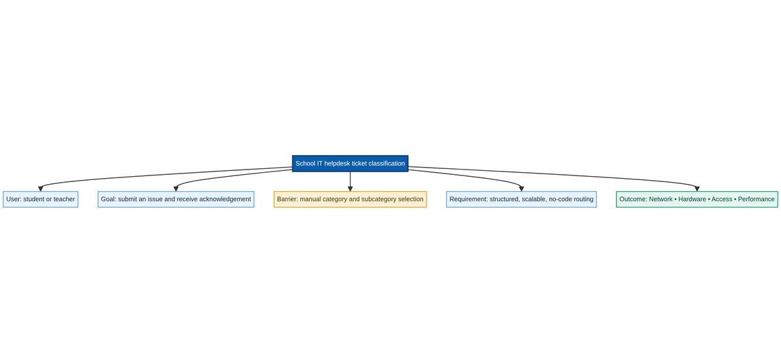
Source: Auto Ticket Classification using Flow Designer project brief
Project scenarios and classification logic:
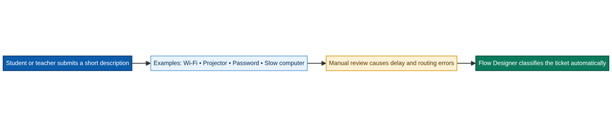
Problem Statement (PS) | I am (Customer) | I’m trying to | But | Because | Which makes me feel
PS-1 | Student or teacher | submit a school IT support request | the request is manually reviewed and categorized by IT staff | many daily requests make manual routing slow and error-prone | uncertain while waiting for the issue to reach the right queue
PS-2 | School IT helpdesk agent | receive complete, correctly routed ticket records | the agent must interpret keywords and update Category and Subcategory by hand | ticket volume grows and inconsistent data makes routing harder | overloaded and concerned about delays and rework

